**Admin Modules**

All customers list:

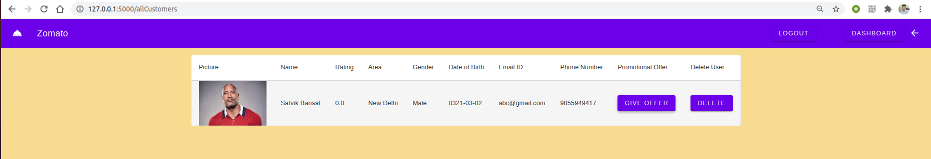

Clicked Give Offer for the customer, but there were no offers available in the offer list. So we first add an offer to the offer list.

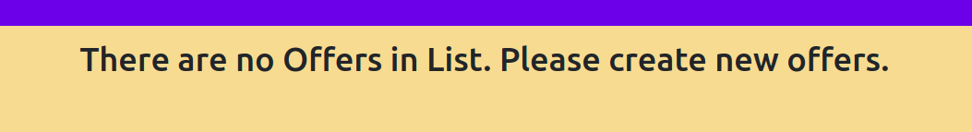

Button for adding new offers and list for showing already created offers.

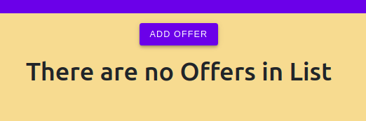

Create an offer by providing the required data.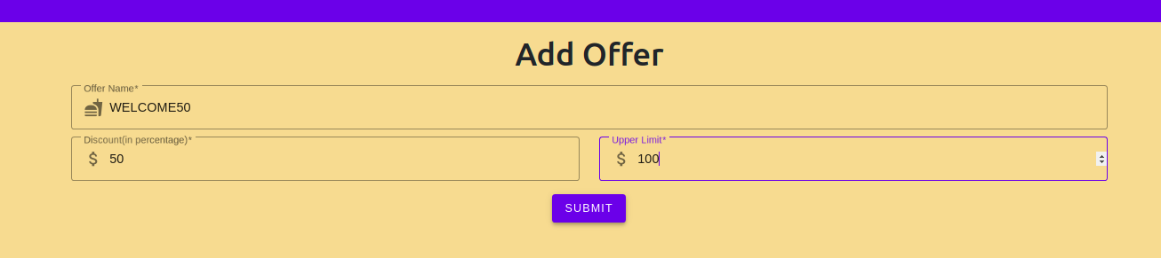

Now the offer will be added in the offer list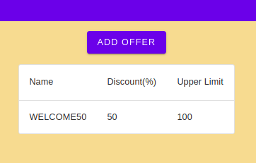

Now we will go to all customer list and give the created offer to the customer

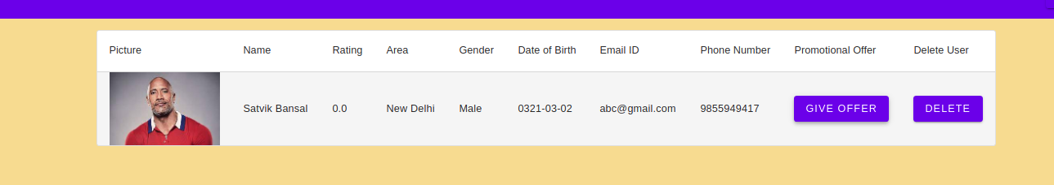

Click Give Offer to give the offer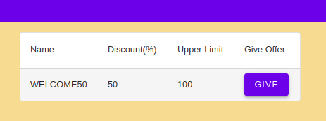

Now the offer is added to the customer

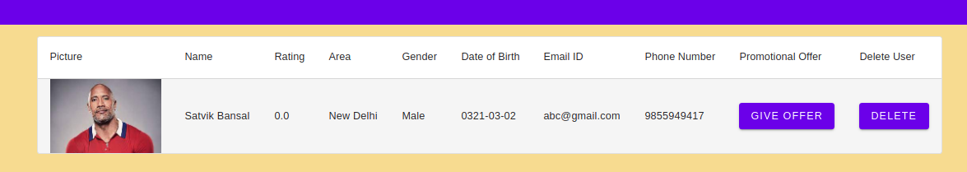

See all restaurants (currently the first restaurant is not recommended)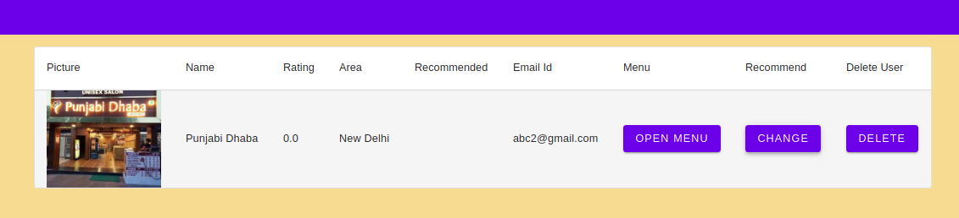

Recommend the first restaurant

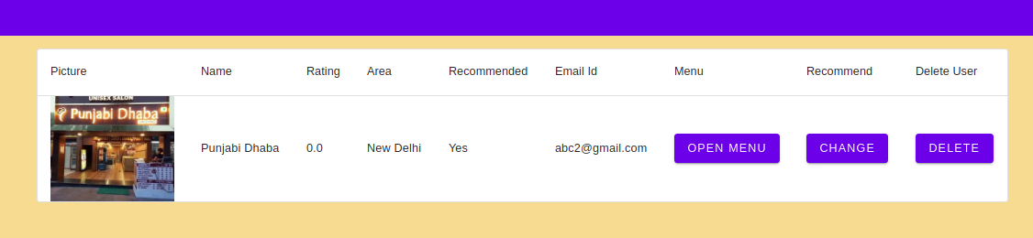Open menu for the first restaurant (currently none of it is recommended)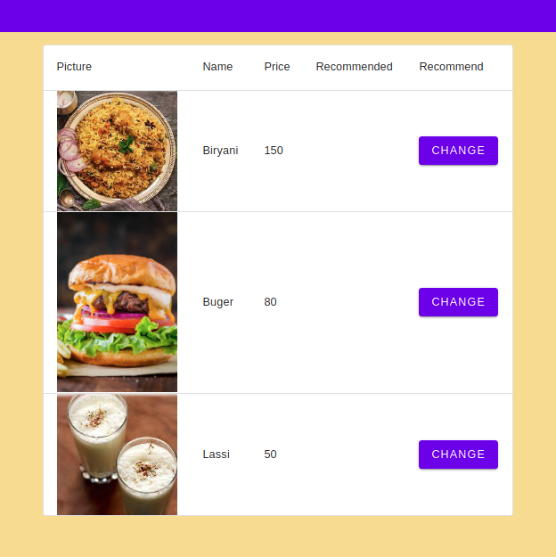

Recommend the food item “Burger”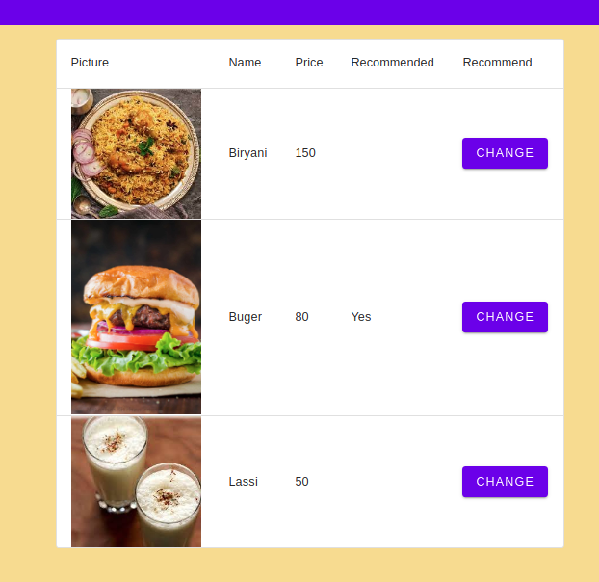

See all delivery agents

